**LAB 4**

**Exercise:**

**Q1) Create a secret message containing your name and roll number along with "The World is Real. Be good to yourself." Embed the file 'secretmessage.txt' inside the cover file 'coverfile.jpg' and name the output stegofile 'hiddenmessage.jpg'. What is the full command you would use to do this?**

**Commands:**

**Embed Secret Messsage:**

**steghide embed -cf myimg.jpg -ef secret.txt**

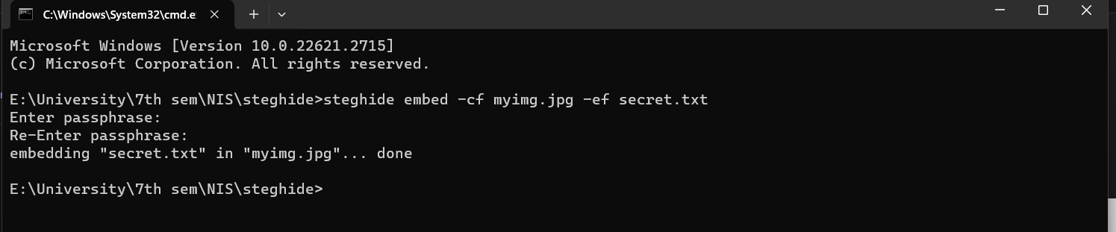

**Q2) Extract the secret message send by your fellow student. What is the message and how to extract it?**

**Steps for Extracting the Secret Message:**

**Step 1:** Paste the fellow student’s image file in the steghide folder**.**

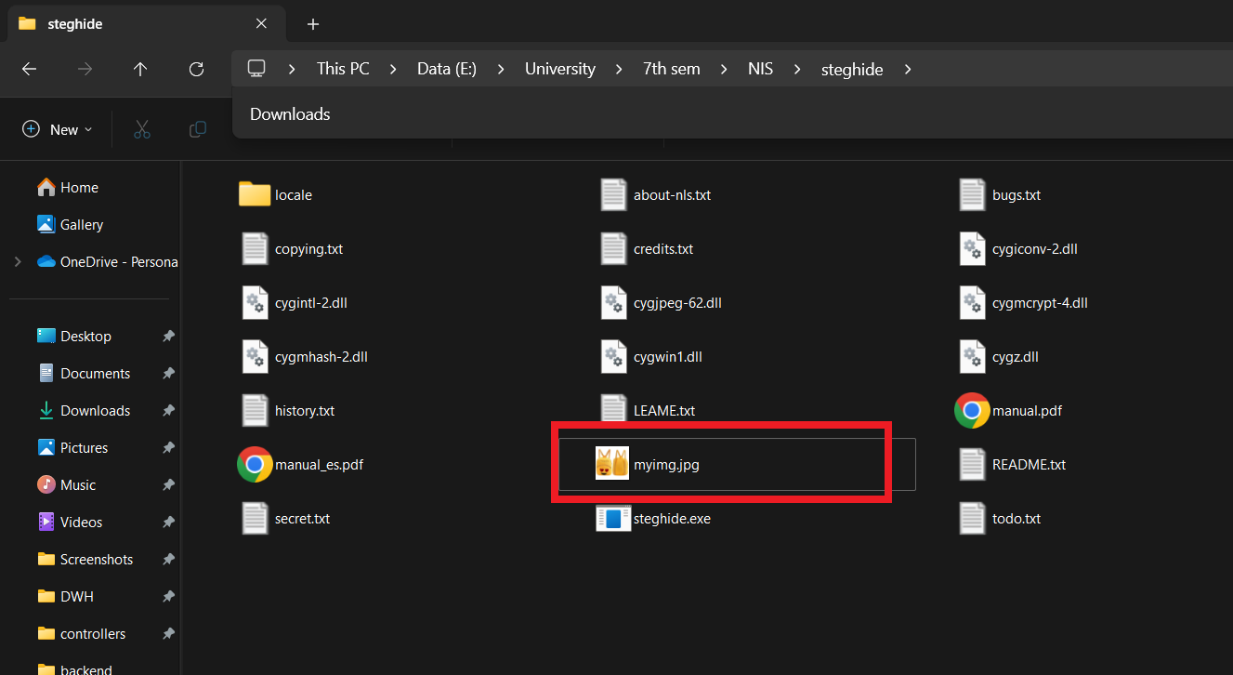

**Step 2:** Open cmd in the steghide folder and write the command written below for extracting the secrect message:

**steghide extract -sf myimg.jpg**

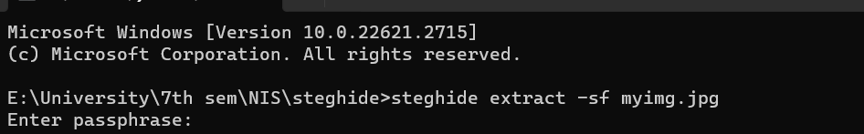

**Step 3:** We must have the passphrase to generate the secrect message text file:

i.e. passphrase: **123**

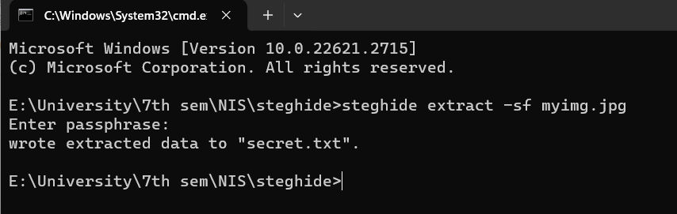

**Step 4:** The **secrect.txt** file will be generated in the steghide folder.

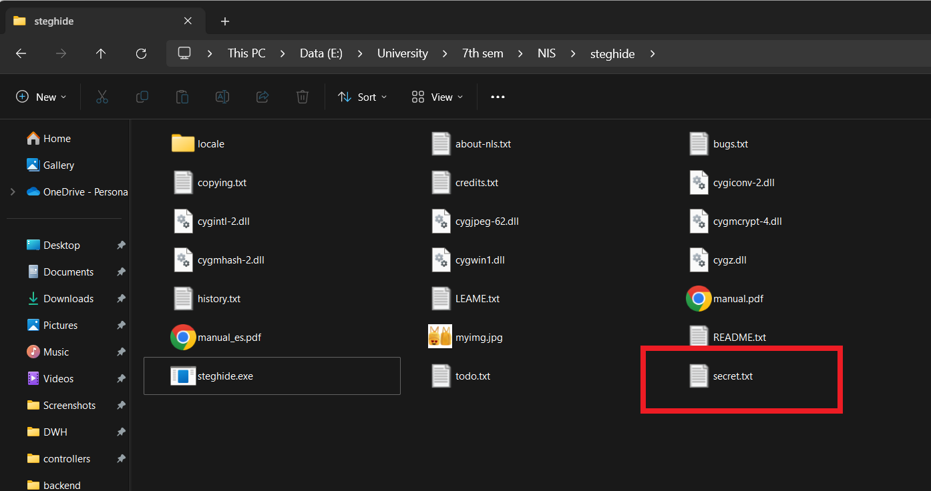

**Assumption:**

It is necessary that anyone who’s extracting the secret message from the image must know the “passphrase” to generate the secret message txt file.